You have the code and files to create the following webpage. Unfortunately, there are some errors with the code. Debug the code and fix it so the web page works. You may use your computers to work on it but must write your corrections in the code on this paper (reverse side).

Note: The html file must remain in the Web Page folder and both the image and video files must remain in the Media folder. All tags must have an open and closed tag with the exception of the <img> tag.

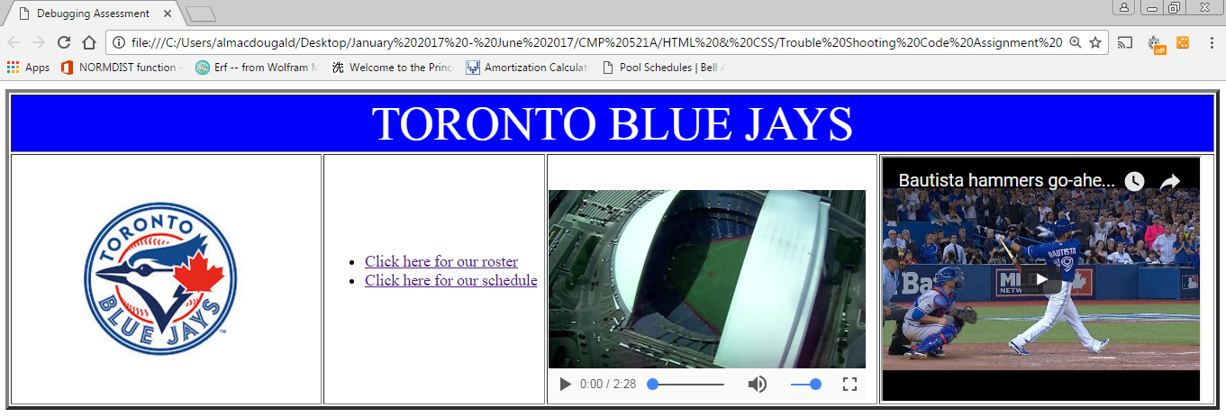

Clicking on the image will take you to <https://www.mlb.com/bluejays> . The image is in the Media Folder. It will open in a new window or tab.

This is a Youtube video of the batflip.

This is the OkBlueJaysSong.mp4 video located in the Media Folder.